# Analysis of Multi-Family Housing

## The analysis of Coventry's parcel data revealed important insights into the distribution of multi-family housing, the zones where multi-family uses already exist, and areas that may benefit from zoning amendments to allow multi-family developments by right. This summary highlights how multi-family housing is currently restricted and where zoning changes could effectively support more flexible housing development, particularly in the context of the town’s goals to increase housing opportunities. To facilitate multi-family development by right in Coventry, several potential amendments have been suggested which could be made to the zoning ordinance. These changes involve updating zoning definitions, adjusting the Schedule of Zoning District Use Regulations, and modifying dimensional standards to support multi-family housing types.

## After receiving feedback and guidance from town staff and Planning Commission members, our team will draft amendments, where appropriate, to some or all of the Articles of the code of ordinances, as outlined in the *Suggested Changes and Amendments* section of this report.

## Task Description and Purpose

### Description:

* Conduct an analysis of the allowance of two-family, three-family, and multi-family housing by right in certain districts. The Coventry zoning ordinance does not currently permit two-family, three-family, or multifamily housing at all in any zoning district in the Town. They had previously been allowed, but more recent code changes have rendered these uses as prohibited in all zones in Coventry. The Town would like to explore where changing regulations around this type housing to allow it as a by-right use in appropriate areas.

### Purpose:

* To evaluate the distribution of multi-family housing across Coventry's zoning districts and identify opportunities where zoning amendments could allow multi-family developments by right.
* To provide a variety of strategies that, with the Planning Commissions recommendation, will guide our approach to revising the Town’s code of ordinances to allow multi-family housing by right strategically throughout the municipality.

## An Analysis of Existing Multi-Family Uses

#### Geographic Context of Multi-Family Housing in Coventry (Map 1)

* The highest concentration of multi-family housing parcels, as shown in Map 1, is located in the eastern part of Coventry, particularly along RI-116, RI-33, and the surrounding areas.
* The northern and central areas, especially along RI-117 and north of RI-14, host scattered multi-family parcels, primarily of the 2-5 unit variety.
* In the southern part of Coventry, multi-family parcels are concentrated near RI-102 and RI-3, particularly where the roadways intersect. This area shows a small number of mixed-use developments, indicating a blend of commercial and residential use along transportation corridors.
* The majority of multi-family parcels are situated near Coventry’s key transportation routes, including RI-116, RI-117, RI-33, and RI-102. These roads serve as critical arteries, connecting residential areas to commercial centers, schools, and employment hubs. The clustering of multi-family housing near these roads emphasizes the importance of infrastructure in determining the location of higher-density housing

#### Concentration of Multi-Family Housing in R20, GB, and RR Zones (Table 1)

* R20 (Residential 20) Zone: The majority of multi-family housing units (67.32%) are located in the R20 zone, with 365 parcels having 2-5 family units, 27 parcels having 6+ family units, and 20 parcels being designated as mixed-use. Although multi-family housing is not currently allowed by right in the R20 zone, its large presence indicates that many existing developments are non-conforming. This suggests an underlying demand for higher-density housing in areas already built up with infrastructure.
* Rural Residential (RR2, RR3, RR5) Zones: The RR2, RR3, and RR5 zones encompass large rural parcels and account for 13.72% of multi-family housing. While these areas are currently zoned for low-density, single-family homes, the data indicates that there are some multi-family and mixed-use developments scattered throughout these zones. The large parcels in these areas, coupled with existing infrastructure, present opportunities to explore higher-density housing options.
* General Business (GB) Zone: The GB zone already accommodates a mix of 2-5 family, 6+ family, and mixed-use developments, with a total of 37 parcels representing 6.05% of Coventry’s multi-family housing. The mix of residential and commercial uses in this zone suggests its suitability for further mixed-use development.

#### Mixed-Use and Multi-Family Housing in VMC and VRC Zones (Table 1)

* Village Main Commercial (VMC) Zone: Representing 4.74% of multi-family housing in Coventry, the VMC zone has 16 parcels with 2-5 family units, 5 parcels with 6+ family units, and 8 parcels designated as mixed-use. The smaller parcel sizes and commercial nature of this zone make it an ideal area for village-scale development that blends housing and local services.
* Village Rural Commercial (VRC) Zone: With only 3 mixed-use parcels (0.49% of total multi-family housing), the VRC zone is less developed but presents potential for future growth. Its village character and proximity to local amenities make it suitable for multi-family housing in the future.

Map 1:Geographic Distribution of Multi-Family Housing and Mixed-Use Developments in Coventry

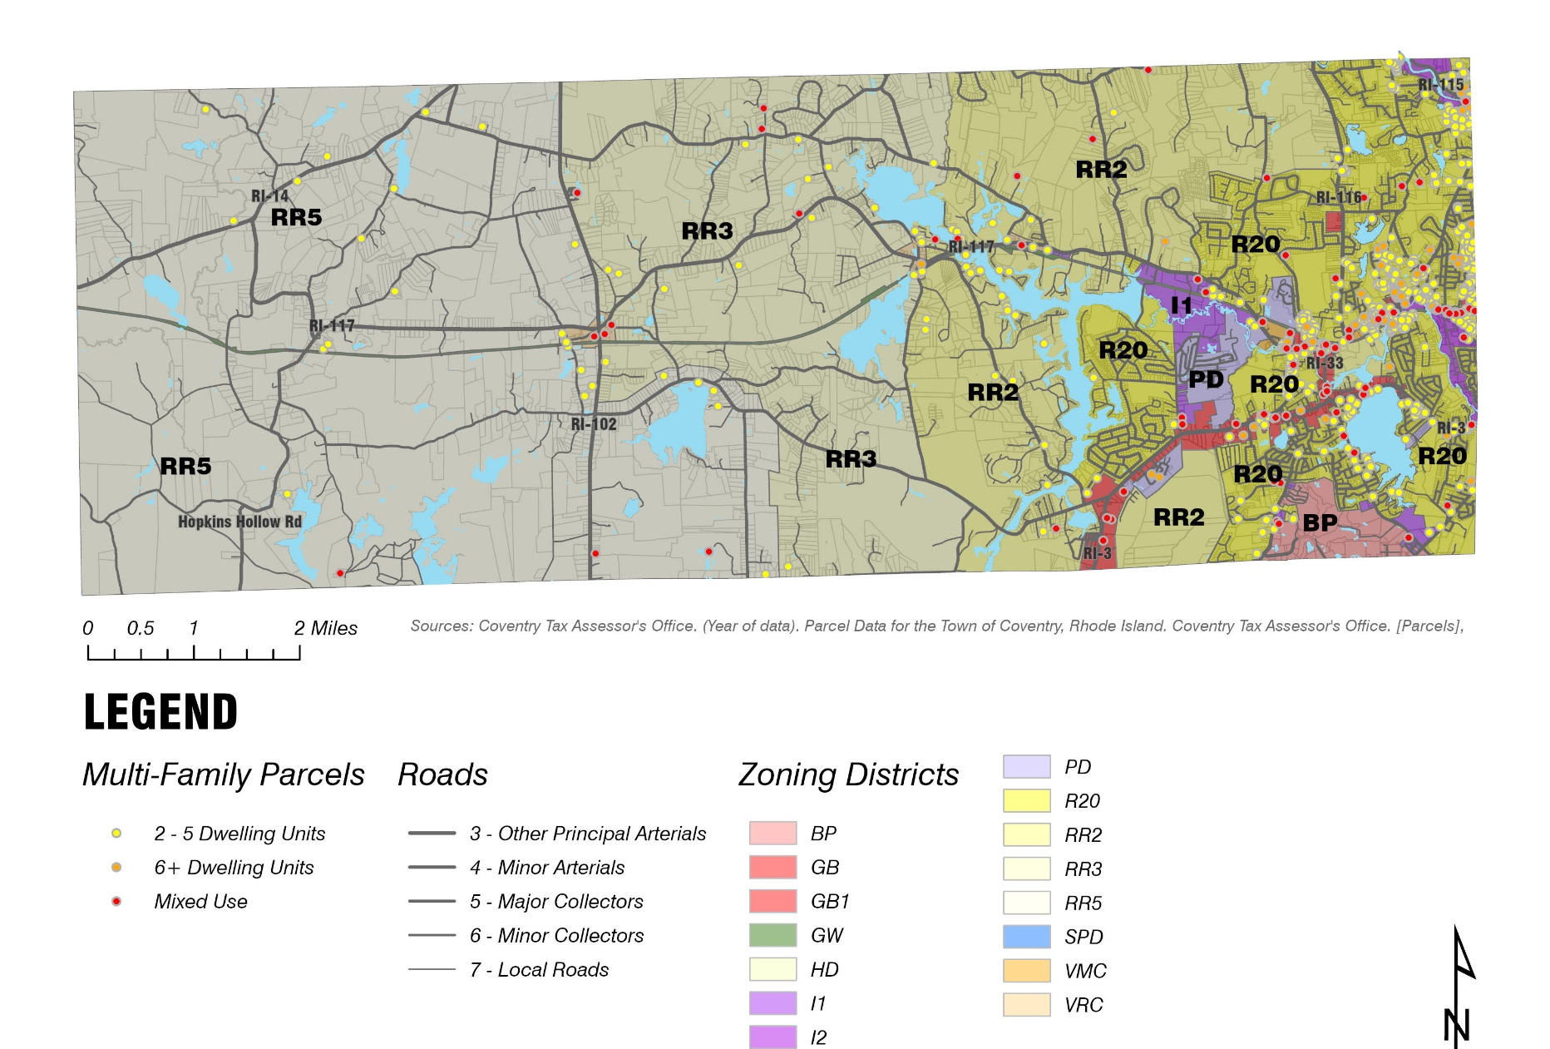

Table : Multi-Family Housing Distribution

|  |  |  |  |  |  |
| --- | --- | --- | --- | --- | --- |
| Zoning District | 2-5 Family Dwelling Units | 6 or More Dwelling Units | Mixed-Use | Total | Total (%) |
| **R20** | 365 | 27 | 20 | 412 | 67.32% |
| **RR2** | 32 | 2 | 7 | 41 | 6.70% |
| **GB** | 14 | 5 | 18 | 37 | 6.05% |
| **VMC** | 16 | 5 | 8 | 29 | 4.74% |
| **RR5** | 21 |  | 3 | 24 | 3.92% |
| **RR3** | 14 |  | 5 | 19 | 3.10% |
| **GW** | 12 | 1 | 4 | 17 | 2.78% |
| **I2** | 8 | 4 | 3 | 15 | 2.45% |
| **GB1** | 3 |  | 3 | 6 | 0.98% |
| **I1** |  | 2 | 4 | 6 | 0.98% |
| **BP** | 1 |  | 2 | 3 | 0.49% |
| **VRC** |  |  | 3 | 3 | 0.49% |
| Grand Total | 486 | 46 | 80 | **612** | **100.00%** |

#### Mixed-Use Potential in GB and GB1 Zones:

* The GB and GB1 zones already support a mix of commercial and multi-family housing, with some parcels containing both apartments and commercial uses. This reflects an inherent flexibility in these zones, making them prime candidates for allowing multi-family housing by right. Given the existing infrastructure and the commercial nature of these zones, further amendments to permit mixed-use developments with multi-family components would be a logical progression.

#### Potential in VMC and VRC Zones:

* Village Main Commercial (VMC) and Village Rural Commercial (VRC) zones are notable for their smaller parcel sizes and existing commercial uses. While these zones currently host fewer multi-family developments, their commercial nature and village character make them excellent candidates for mixed-use zoning amendments that integrate housing with local services. Allowing duplexes, triplexes, and apartments by right in these zones would contribute to a vibrant village atmosphere while addressing housing needs.
* The VMC zone, with its average parcel size around 12,500 square feet, is particularly suited for higher-density residential or mixed-use development, encouraging walkable, community-centered growth. Similarly, the VRC zone, with parcel sizes averaging around 88,000 square feet, offers flexibility for larger developments or village-scale multi-family housing projects.

### . Parcel Size and Dimensional Requirements for Multi-Family Housing:

#### Challenges and Opportunities in Rural Residential Zones (RR2, RR3, RR5):

* The RR2, RR3, and RR5 zones present an interesting case for multi-family housing development. The large parcels, typically ranging from 200,000 to over 400,000 square feet, are vastly underutilized under the current zoning, which limits these areas to single-family homes. Introducing multi-family housing by right, either through cluster developments or allowing duplexes and triplexes, could help alleviate the housing shortage while preserving open space.

#### R20 Zone as a High-Potential Area for Growth:

* The R20 zone, with an average parcel size of about 27,000 square feet, is densely settled with single-family homes but could be a prime candidate for multi-family housing. Rezoning the R20 zone to allow 2-5 family dwellings by right would enable higher-density residential development in areas where infrastructure is already in place, making it easier to support such growth without significant strain on town resources.

Table Average Lot Size (SF) of Multi-Family Housing by Use and Zoning District

|  |  |  |  |  |
| --- | --- | --- | --- | --- |
| Zoning District | 2-5 Family Dwelling Unit | 6 or More Dwelling Units | Mixed-Use | Overall Average |
| **BP** | N/A | N/A | 31,235 | **31,235.00** |
| **GB** | 18,814 | 125,281 | 24,426 | **35,931.43** |
| **GB1** | N/A | 806,484 | 88,815 | **328,037.83** |
| **GW** | 41,602 | 18,603 | 110,876 | **56,549.24** |
| **I1** | 54,138 | N/A | 113,961 | **84,049.83** |
| **I2** | 14,425 | 13,564 | 22,589 | **15,827.80** |
| **R20** | 20,145 | 70,841 | 94,874 | **27,095.30** |
| **RR2** | 191,816 | 76,682 | 499,387 | **238,711.90** |
| **RR3** | 185,835 | N/A | 318,930 | **220,859.89** |
| **RR5** | 164,588 | N/A | 2,088,425 | **405,067.58** |
| **VMC** | 10,739 | 14,370 | 15,029 | **12,548.55** |
| **VRC** | 58,917 | N/A | 104,011 | **88,979.67** |

## Suggested Changes and Amendments:

#### Article II: Definitions

* Add New Definitions:
  + Triplex: A residential building with three separate dwelling units, each with independent entrances, often sharing walls.
  + Fourplex: A residential building with four separate dwelling units, typically designed with shared walls or floors.
  + Townhouse: A multi-story residential unit attached to one or more other units, each with its own entrance and often featuring a small yard or parking area.
  + Live/Work Unit: A space that combines residential living quarters with a work area for commercial or business use, typically suited for small-scale business operations.
* Incorporating these new definitions will create clarity and legal certainty for the introduction of multi-family housing types across the municipality, ensuring they are distinct from existing housing types like single-family homes or traditional multi-story apartments.

#### Article VI: Zoning District Use and Dimensional Regulations

* Update Permitted Uses: Add new multi-family housing types—triplexes, fourplexes, townhouses, and live/work units—as permitted uses by right in districts such as R20, VMC, VRC, GB, and even select RR zones. This will ensure that these new housing types are recognized across different zones, fostering diverse housing options.
* Modify the table to permit multi-family housing types without the need for special use permits, especially in areas near existing infrastructure or along major roadways. This will encourage development in the areas where it is most practical.

#### Article IX: Supplementary Regulations

* Update this section to relax certain dimensional and siting requirements (e.g., setbacks, height restrictions, parking requirements) specifically for the new housing types defined in Article II (triplexes, fourplexes, townhouses, live/work units). This will ensure that these housing types can be developed efficiently, without needing excessive variances or special permissions.

#### Article XIII: Residential Cluster Development

* Introduce more flexible provisions that allow for clustered multi-family housing developments in RR2, RR3, and RR5. This approach would enable higher-density housing (e.g., duplexes, triplexes, fourplexes) on large rural parcels, while preserving open space and reducing infrastructure costs. The goal is to balance rural character preservation with increased housing diversity.

#### Subdivision and Land Development Regulations.

* Expand the subdivision and land development regulations to streamline the approval process for larger-scale multi-family developments and to ensure that multi-family units can be built in appropriate areas while following clear and specific procedures.
* Include specific guidelines for multi-family developments in GB, VMC, and VRC zones, where mixed-use projects are more feasible and can integrate commercial activities with residential uses.

#### Summary of Recommended Changes

* By making these targeted amendments to Coventry’s zoning ordinance, the municipality can create a framework that accommodates a wider variety of housing options while simplifying the development process for multi-family housing. Our team recommends pursuing all the strategies as outlined in this document. These changes will define new multi-family housing types and update current use regulations, which will in turn allow for the development of multi-family housing in appropriate locations throughout Coventry, meeting the growing demand for diverse and sustainable housing while also bringing hundreds of non-conforming properties into conformance with the requirements of the code of ordinance.