**History of Unpaid Firefighters**

**Coventry firefighters can be paid after deal is struck with credit union**

Shaun Towne

10 years ago

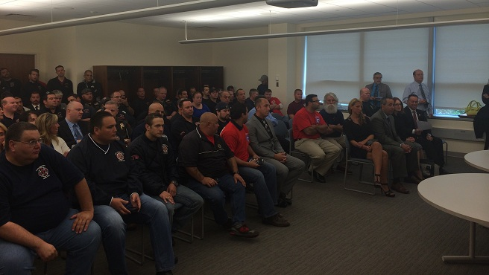

COVENTRY, R.I. (WPRI) — After going more than a month without pay, Coventry Fire District firefighters may soon receive paychecks after a deal was made between the district’s board, the firefighters union and Coventry Credit Union.

The fire district has been in financial despair for months, and it came to a head last week when the credit union [cleared out the fire district’s accounts](http://wpri.com/2015/09/30/coventry-fire-district-has-bank-funds-closed/), saying the district was $456,000 in debt to the bank. The move prompted three of the district’s 14 firefighters to retire or resign.

A court-ordered meeting was held Monday before Superior Court Judge Brian Stern to sort out some of the district’s problems. Since the district couldn’t afford police detail, the board had been reluctant to schedule a meeting without an officer present. The Kent County Courthouse’s police detail was there to ensure good behavior.

Judge Stern blamed many of the district’s issues on the board’s lack of actions.

“In this case, not making a decision has had major consequences,” he said.

A public meeting turned private when the board voted to move it to executive session.

After meeting for more than two hours behind closed doors, both sides emerged with a deal. The credit union agreed to release the district’s funds as long as the district makes interest-only payments on their loan.

It was decided that the firefighters union will control 70 percent of the money for members’ salaries and benefits, while the remaining 30 percent will be used by the board to pay for operations and bills. The split in funding will be in effect until Nov. 15, meaning both sides will need to come up with a permanent solution before then.

“Will it make everyone whole? No. We are still tremendously short of money,” said board chairman Frank Palin. “We are holding it together with wire and duct tape for the time being.”

When the judge asked if the firefighters will remain on the job, Gorman nodded his head in affirmation.

“Many people, including firefighters, are just sick of the whole situation, and we just need to move forward,” he added.

The judge said he was “very, very pleased” with the decision, and expressed thanks to Coventry Credit Union for offering the deal. He implored both sides to take advantage of the next six weeks to meet and find solutions to their problems.

Wednesday, January 16, 2013

*Paul J. Spetrini, GoLocalProv News Editor*

When [**the Central Coventry Fire District**](https://www.golocalprov.com/news/the-highest-taxed-fire-districts-in-ri/) revealed last fall that it had a $1.6 million budget deficit and would seek receivership, many residents in the small Rhode Island area who had never even attended a fire district meeting wondered how such a big problem could have gone unnoticed for so long.

**The problem was so bad that firefighters in the district went weeks without pay and, if the current projections hold true,** the district’s taxpayers will soon be asked to foot a tax increase of up to 60 percent to make up the now $2 million hole.

Not surprisingly, Coventry’s representatives in the General Assembly want answers for their constituents and, yesterday, they made a plea to the Attorney General for assistance.

“The people of the district as well as the fire personnel deserve an answer as to where that money has gone,” Kettle said in a press release. “The fire district is currently in receivership and if criminal actions led to the current situation, we need to know.”

**A dire situation**

According to multiple sources, the district is currently facing a $2.2 million dollar deficit

“The Central Coventry Fire District is in a dire financial situation right now,” Chippendale said. “There is a special master assigned to the district to try to salvage essentially the entire department because it is completely fiscally unsustainable. Iit just can’t even go forward from this point.”

Chippendale said the problem stemmed from poor accounting practices and a lack of accountability.

“Regrettably, whenever there’s these small entities, like a fire district … there is no oversight,” he said. “These are mostly self-governing bodies and if those charged with governing themselves are inclined to potentially not follow the rules, either maliciously or through negligence, something like this can very easily get to this point.”

According to Chippendale, the legislators believe the problem begin with a “simple malfunction or simple misunderstanding of some financial revenues” that gave those in charge a “false impression that there may have been more funds available than there actually were.

“It dominoed from there,” he said.

**The root of the matter**

Because the legislators don’t know the specifics of what went wrong and who is to blame, they’ve asked Kilmartin to step in.

“We want to know what the specifics were because this may have been a simple mistake,” he said. “And if that’s the case then we need to work together to get to the best solution for the residents of that fire district but if it’s much more than that, then the Attorney General will have to take that matter from there.”

**The Central Coventry Fire District has a budget of approximately $6.6 million**, Chippendale said, and any attempt to plug the projected shortfall would also have to take into consideration hiring changes and policies put in place in previous years that relied on incorrect information.

“There are extra staff hired based on the false assumption that they had more money than they really did so it’s a two-pronged issue,” he said. “The two million dollars, it’s the two million dollars itself and second of all it’s the outcome of the decisions made thinking they had two million more than they did.”