Coventry Municipal Fire Commission:
Report on the Study of a Municipal Fire Department
December 2, 2025

Executive Summary
In the interest of fiscal efficiency and to maintain and increase public safety, the Coventry Town Council created the Municipal Fire Commission. The Commission, created by Resolution No. 2024-66 in August 2024, was charged with preparing a comprehensive implementation plan to be presented to the Town Council to establish a municipal fire department that would fall under the purview of the Town, including financial control. The creation of the Commission follows on the assessment of fire services conducted by Dynamix Consulting Group. The January 2024 report by Dynamix yielded three options:
- maintain the status quo;
- merging into one quasi-public district; and
- establishing a municipal fire department.
This report outlines the findings of the Commission in regard to the current independent fire district model staffing, assets, liabilities, and legal and financial concerns and the path forward should the Town Council decide to form a municipal fire department.

Table of Contents
Executive Summary 1
1.0 Commission Scope and Deliverables 3
2.0 Commissioners 3
3.0 Background 4
4.0 District and Town Geographics 4
5.0 Upcoming Known Town Developments 7
6.0 District Financial Challenges and Current Instability 7
7.0 Findings 9
7.1 Acquisition and inventory of District property 9
7.2 Acquisition and inventory of District assets including equipment and apparatus 9
7.3 Acquisition and Inventory of District Personnel 14
7.4 Inventory of current third-party District contracts and transition planning for associated services 18
7.5 Assessment of District building and asset management 19
7.6 Assessment and transition planning from District tax collection to Town collection 20
7.7 Audit of collective District liabilities and outstanding debts 20
7.8 Assessment and Implementation Plan of necessary, policies, codes, and ordinances to be adopted by the Town Council 20
7.9 Assessment and implementation plan of necessary state legislation to accompany the transition 20
7.10 Assessment of recurring revenue and fee structure for a municipal department 20
7.11 Draft budget for a municipal department for fiscal year one 22
7.12 Assess the overall fiscal impact on the Town budget 24
8.0 Further Considerations 26
9.0 Comparative Evaluation of Service Models 27
10.0 Conclusion 28
Table of Figures
Figure 1: Fire District Geographic Area Map 6
Figure 2: Town of Coventry Population Density 7
Figure 3: Apparatus Inventory 11
Figure 4: Inventory of Equipment 15
Figure 5: NFPA 1710 Residential Structure Fire Staffing Requirements 18
Figure 6: Third Party Maintenance Contracts 20
Figure 7:Tax Roll Assessment 22
Figure 8: Combined Tax Roll Assessment 23
Figure 9: Municipal Fire Department Draft Budget 25
Figure 10: Town Tax Rate Increase 26
Figure 11: Tax Rate Increase by District and Residential Property Impact 27

Attachments
Attachment A: Tax Assessor Fire District Properties
Attachment B: Solicitor Report on Municipal Fire Department Formation
Attachment C: MERS Pension Liability Information

1.0 Commission Scope and Deliverables
In its founding resolution, the Commission was charged with developing an implementation plan addressing:
- Acquisition and inventory of District property
- Acquisition and inventory of District assets including equipment and apparatus
- Acquisition and inventory of District personnel including associated collective bargaining agreements, transition planning to a singular collective bargaining unit, and associated department leadership structure
- Inventory of current third-party District contracts and transition planning for associated services
- Assessment of District building and asset management and draft of five-year capital improvement plan
- Assessment and transition planning from District tax collection to Town collection
- Audit of collective District liabilities and outstanding debts
- Assessment and implementation plan of necessary policies, codes, and ordinances to be adopted by the Town Council
- Assessment and implementation plan of necessary state legislation to accompany the transition
- Assessment of recurring revenue and fee structure for a municipal department
- Draft budget for a municipal department for fiscal year one and a three-year budget projection
- Assess the overall fiscal impact on the Town budget

2.0 Commissioners
The Municipal Fire Commission members include:
- Chair-Hillary V. Lima – on Commission until October 02, 2025
- Vice-Chair - JP Verducci – Chair as of October 02, 2025
- CCFD Lieutenant Kevin McCann, Local 3372
- HHFD Captain Daniel McAloon, Local 4824
- Bryan Testen, Anthony Fire District-on Commission until June 17, 2025
- Russell McGillivray, Central Coventry Fire District
- Peter Rondeau, Hopkins Hill Fire District
- Jillian Winemiller, Western Coventry Fire District
- Daniel Parrillo, Town Manager
- Robert Civetti, CPA, Finance Director
- Stephen J. Angell, Esq., Town Solicitor – on Commission until October 01, 2025
- Chief Rick Heise, Coventry PD – non-voting member -retired June 30, 2025

3.0 Background
As in many Rhode Island towns, fire districts were historically created in association with the mill villages where they were located. Some have merged through the years, but the current makeup of the Town of Coventry includes four independent fire districts:
- Coventry Fire District (CFD)
- Central Coventry Fire District (CCFD)
- Hopkins Hill Fire District (HHFD), and
- Western Coventry Fire District (WCFD).
These districts operate independently from each other and the Town of Coventry, and each have their own separate taxing authority. Each district has its own district elected board of directors, fire chief, platoon models, separate budgets, separate tax office, administrative staff, treasurers, attorneys, by-laws, and station staff. In addition, there is one union representing CFD, CCFD, and HHFD. WCFD does not currently have a union. To establish a tax rate and budget each year, the districts require an in-person vote from their taxpayers at their own respective separate annual meetings. Each district has a different fiscal year.
Each of the four fire departments operate independently as outlined above. However, it is also crucial for them to work together to provide mutual aid to each other when required. This can include mutual aid for when more manpower is required at both medical and fire events, as well as when the emergency call originates from a district that is already out of quarters at a different call.

4.0 District and Town Geographics
The four Coventry fire districts include five fire stations, with Central Coventry Fire District being comprised of two fire stations. Each fire district’s geographic area and the location of each of the fire stations can be seen in Figure 1 below.
The address of each fire station is as follows:
- Station 1: Coventry Fire District (Anthony)
571 Washington Street
- Station 4: Central Coventry Fire District
240 Arnold Road
- Station 6: Hopkins Hill Fire District
1 Bestwick Trail
- Station 7: Central Coventry Fire District
2847 Flat River Road
- Station 8: Western Coventry Fire District
1110 Victory Highway
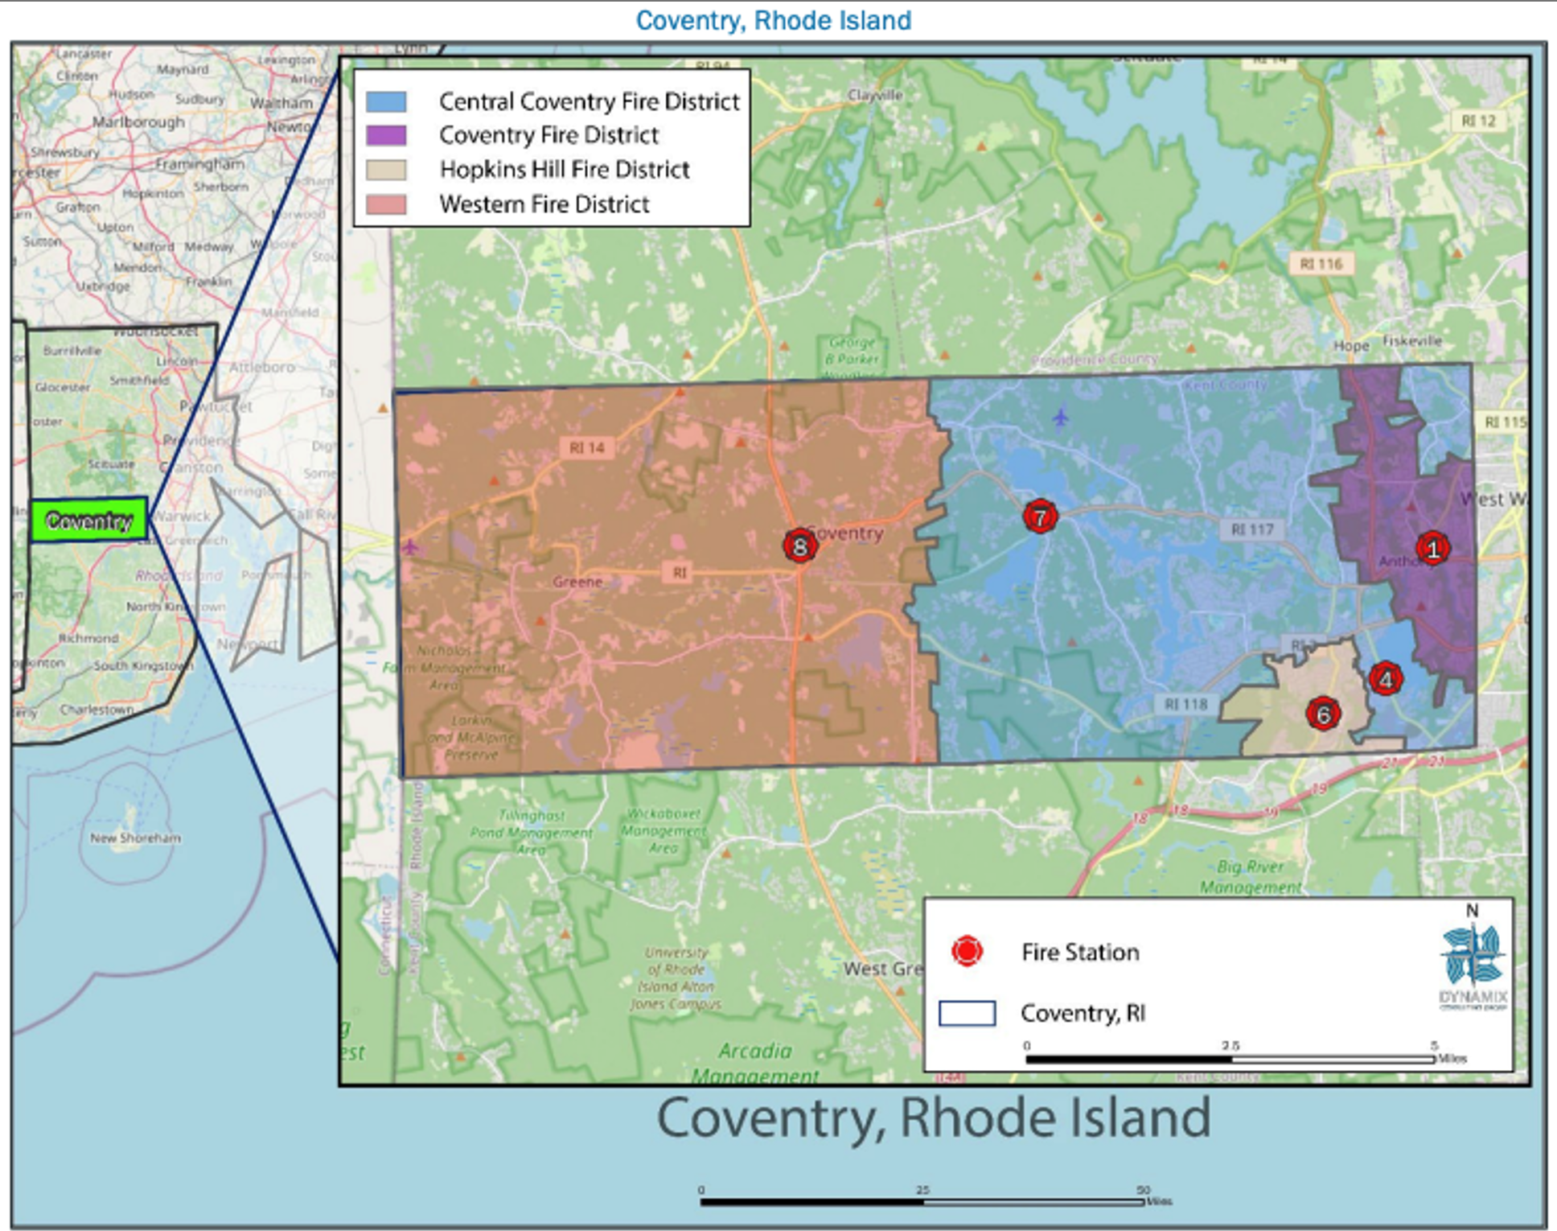
Figure 1: Fire District Geographic Area Map
As seen in Figure 1 above, the majority of the fire stations are located on the eastern end of town. This coincides with the population density of the town from 2023, as shown in Figure 2 below. As Coventry is unique in its geographic size and area, other considerations besides the population density were considered in this study, such as response time to various areas of the districts, and staffing levels at each station later in this report.

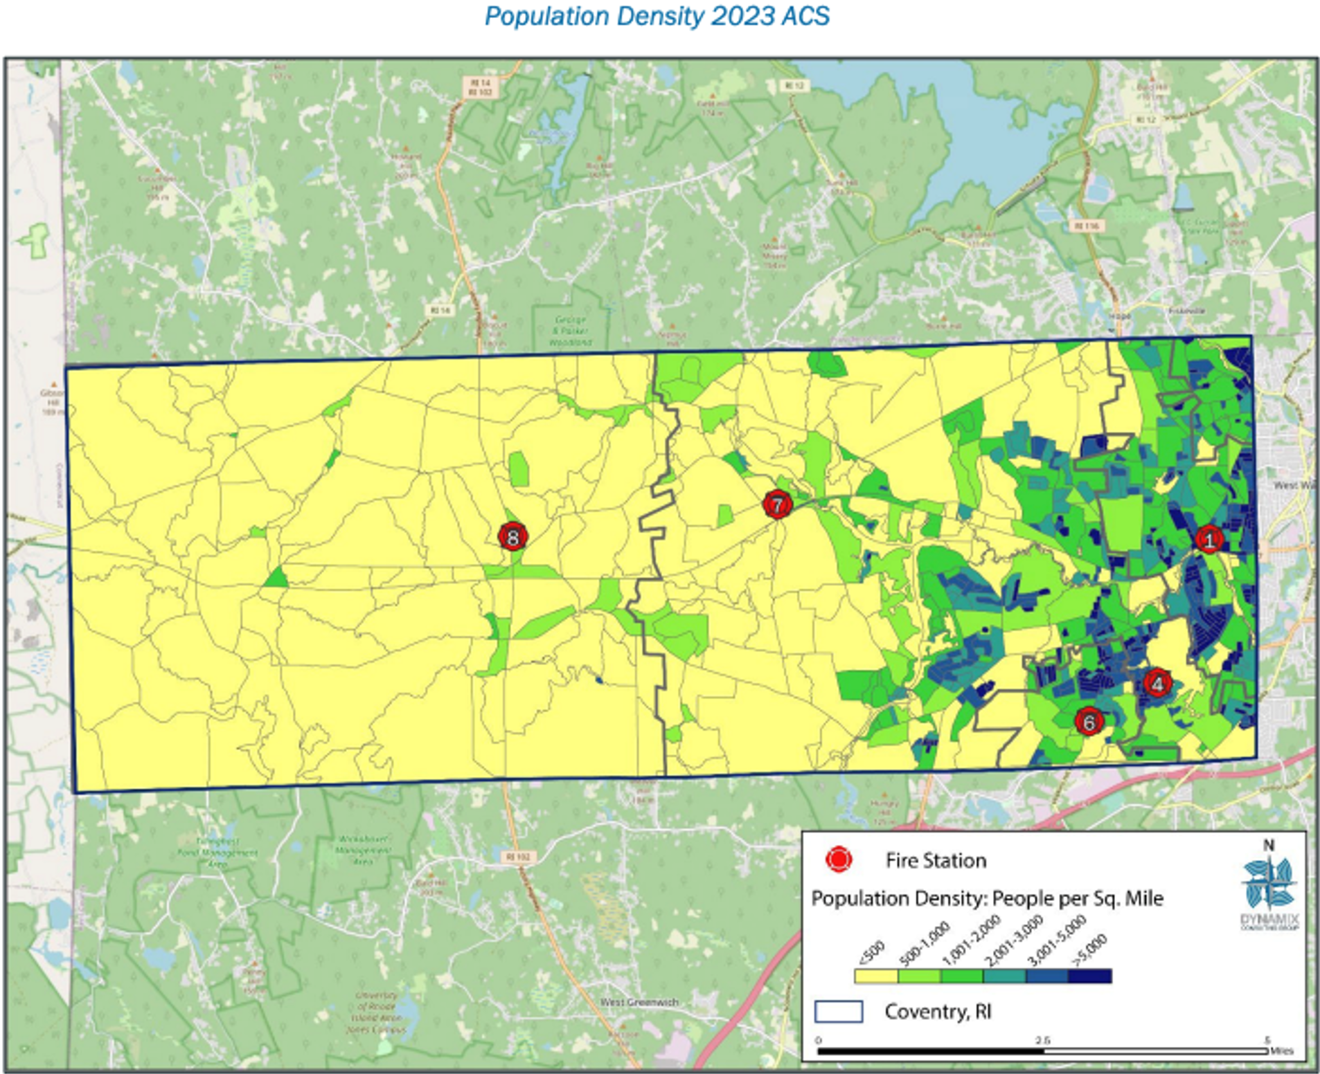
Figure 2: Town of Coventry Population Density
As mentioned above, Coventry is unique in its geographic size and length. The Commission took this into consideration when discussing station and staffing needs, as well as potential for growth. To contextualize this, Coventry’s fire and EMS needs were benchmarked against similar municipalities:
- Coventry has the largest land area among similar municipalities. The Town is 59.5 square miles and has historically seen 120 calls per square mile. This is compared to West Warwick at 8.1 square miles and 1,100 calls per square mile, and North Providence at 5.8 square miles and 1,445 calls per square mile.
- Total call volume of Coventry has historically been approximately 7,200, with calls per 1,000 residents being 199. While the total call volume is similar, it is lower than Johnston at 286 and North Providence at 240.
This lower density of calls, combined with the larger geographic footprint, contributes to slower response times, especially in the western end of town. This metric also reinforces and highlights the need for a well distributed staffing plan, additional coverage, and strategic station placements, particularly in the rural areas of Town.

5.0 Upcoming Known Town Developments
There are known developments that are in the works in various locations in Coventry. This upcoming growth will increase the need for fire and EMS services. Before the new residents move in and while construction is underway, there will be an increased need for fire marshal and life safety inspection services as well. Substantial development that is known at the time of this report being written includes:
- 1,112 residential units (750 unit apartments, 98 duplexes, 83 duplexes) and some commercial development in the Centre of New England. These units could result in an additional 3,000 residents, with a percentage of the residential units being low to moderate income units.
- 218 living units and 60,000 sq.ft. of commercial development for New London Turnpike
- Approximately 176 residential units are planned for the eastern Tiogue section of Town.
- Approximately 90 residential units are planned for New London Preserve.
- Approximately 120 residential units (singles and duplexes) are planned for the area at the intersection of Nooseneck Hill Road (Route 3) and Harkney Hill Road (Route 118), with a percentage of the residential units being low to moderate income units.
- A 232 bed nursing home facility is planned for Center of New England.
- 76 residential units at Oaks at Hope Furnace (Road).

6.0 District Financial Challenges and Current Instability

Budgeting
With the fire districts operating independently and not currently under Town purview, there have been instances at annual budget meetings where voters rejected budgets. This has recently been the case due to voters’ negative reactions to political issues, news reports, and other news outlets postings and have resulted in an eroding of confidence in some Districts’ leadership and budgets being rejected.
Examples of district instability stemming from operating budgets not being accepted by district taxpayers include the extended period of time where personnel in CFD went unpaid. In addition to this, within the last five years, the lack of approval of the CCFD budget for multiple cycles has resulted in Rescue 7 being taken out of service. This full-time rescue was vital to the western end of Coventry, and its closure has resulted in more mutual aid coming from WCFD to CCFD and other districts.
Most recently, CFD had an unnoticed and unreported financial issue of approximately $400,000 this year. In this case, the fire district taxpayers are responsible for this. This could be in the form of a loan from another district, general revenue appropriation, district tax increases, among other options. Under a municipal design, this oversight would be much harder to occur. If financial issues do unexpectedly arise, there is the opportunity to draw from an entire department to solve it and not a smaller independent district, leading to a smaller bill for individuals.

Rescue 7 Closure
Due to firefighter retention issues and a hardship to recruit new firefighters to the districts, Central Coventry Fire District had to take rescue 7 offline which has significantly impacted service certainly in Coventry overall, but more specifically, for the Western end of Coventry which already has very long service wait times.
With more mutual aid coming from WCFD, the entire western half of the town becomes unmanned, which increases call times dramatically to those taxpayers. For example, WCFD has two nursing homes within its boundaries. Analysis was done on response times if WCFD personnel are at another call and not in quarters (personnel man one truck at a time, whichever is dispatched first). It was seen that for the furthest site, located on Plainfield Pike, it would take the next closest Rescue (Rescue 6) out of Hopkins Hill Rd, 15 miles away, an average response time of 18 minutes. A fire event would require more apparatus from further away and/or from surrounding towns to respond. It should be noted that mutual aid also goes to / comes from other surrounding towns, but only once the apparatus in Coventry is exhausted.
While the eastern end of town has a greater population density and call volume, the western end of town cannot be ignored. Taxpayers are demographically an aging population. Although fewer calls, the western end of town sees events that require more manpower, such as cardiac arrests and strokes. It is imperative that there is appropriate staffing levels, and if a municipal fire department is created, it should be a priority to fully man two apparatus at Station 8 or put Rescue 7 back in service, and ideally have both action items happen in the near term.

Mutual Aid Turmoil
Another example of current instability is the mutual aid staffing of the old Harris portion of
CCFD. The current run cards include immediate mutual aid from CFD, as that station is closer
than the Arnold Road station of CCFD. However, as the Harris section of Town is in CCFD and
not CFD, it is considered mutual aid. Currently, the CFD BoD is preparing a legal notice to
CCFD stating that they will no longer be responding to the Harris section of CCFD with their
engine as it does not constitute as mutual aid when the CCFD apparatus are in service and are
sending the CFD engine as it is closer. The majority of these calls are for rescue services and
CCFD does not want to forfeit rescue recovery revenue. This is a prime example of where the
fire district model is not working. The Dynamix report warned the town of imminent and
catastrophic financial and operational collapse of public safety services if nothing changes, and
this is a real time example of it playing out.

Manpower
As mentioned above in the budgeting section, there is difficulty gaining and maintaining manpower in the fire district model. This is due to various reasons:
WCFD is a combined district, utilizing full-time and per diem personnel. Many times, the full-time personnel are hired from the per diem pool. These members use WCFD as a steppingstone department to a larger municipal department. This would be limited if a municipal fire department was formed as there would be greater benefits, such as being protected in a union.
CCFD has procured a negative view from taxpayers in years past, which has caused budget issues, talked about above. This has caused them to be on news outlets in a negative light, causing a smaller hiring pool when needed. Additionally, as the district does not have full staffing, members are required to stay for sometimes days at a time. This is exhausting, causes burnout, and puts a strain on home relationships, causing those members to leave for other more stable departments.
Years back, CFD had a budgeting crisis that caused members to go unpaid. Many personnel left for departments that were more stable and would reliably pay.

7.0 Findings

7.1 Acquisition and inventory of District property
There are six properties that are owned by the four fire districts. These properties include Station 1, 4, 6, 7, and 8, with addresses outlined in Section 5.0 of this report. In addition to these five fire stations, WCFD also has the Greene Station, located at 2 Hopkins Hollow Road, and is currently used as a storage facility.
Three of the four fire districts have communicated to the Fire Commission that they are willing to sign their respective properties to the Town of Coventry without selling them for market value. The exception to this is WCFD, whose Board of Directors have communicated that they are largely not in favor of the Town taking over the fire district and have indicated that their property would only be given to the Town to use as part of this municipal fire department if the Town were to purchase it for fair market value.
The official property assessments that were completed by Catalis can be seen in Attachment A. The values for each property, including property and land, are indicated below from these assessments:
Washington Street (Station 1): $999,000
Arnold Road (Station 4): $613,900
Bestwick Trail (Station 6 and adjacent garage): $556,400 and $208,900
Flat River Road (Station 7): $657,300
Victory Highway (Station 8): $1,963,400
Hopkins Hollow Road (Greene Station): $384,300
The properties from CFD, CCFD, and HHFD would be absorbed in the case of a municipal. The Chairman of the WCFD BoD has indicated that a formal assessment has not been completed but the values given are a minimum value for insurance replacement of buildings without the contents. A formal assessment would need to be completed, but the values received from the insurance company are $3,352,608 for the Summit Station property, and $328,668 for Greene Station. Acquisition of these properties and other means of acquisition besides purchase can be found in the Solicitor’s report, Attachment B.

7.2 Acquisition and inventory of District assets including equipment and apparatus
Much like the acquisition of district property, three of the four fire districts have communicated to the Fire Commission that they are willing to sign their respective equipment and apparatus to the Town of Coventry without selling them for market value. The exception to this is WCFD, whose Board of Directors have communicated that they are largely not in favor of the Town taking over the fire district and have indicated that their equipment and apparatus would only be given to the Town to use as part of this municipal fire department if the Town were to purchase it.
A full inventory of apparatus was compiled across all of the four districts, which can be seen in Figure 3 below.
A full inventory of gear and equipment was compiled across all of the four districts, which can be seen in Figure 4 below.
Apparatus, gear, and equipment ages and condition vary widely, and some are approaching their end of life. Further steps to be taken are determining what maintenance agreements are in place, and whether contracts need to terminate upon conversion to municipal. Centralizing maintenance agreements would result in cost savings.

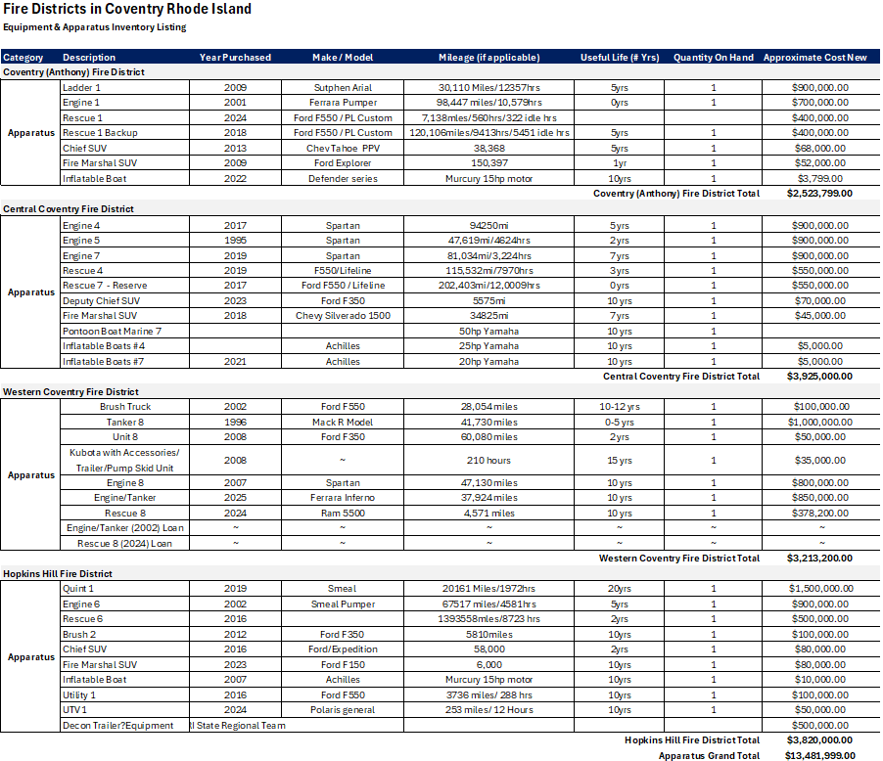
Figure 3: Apparatus Inventory
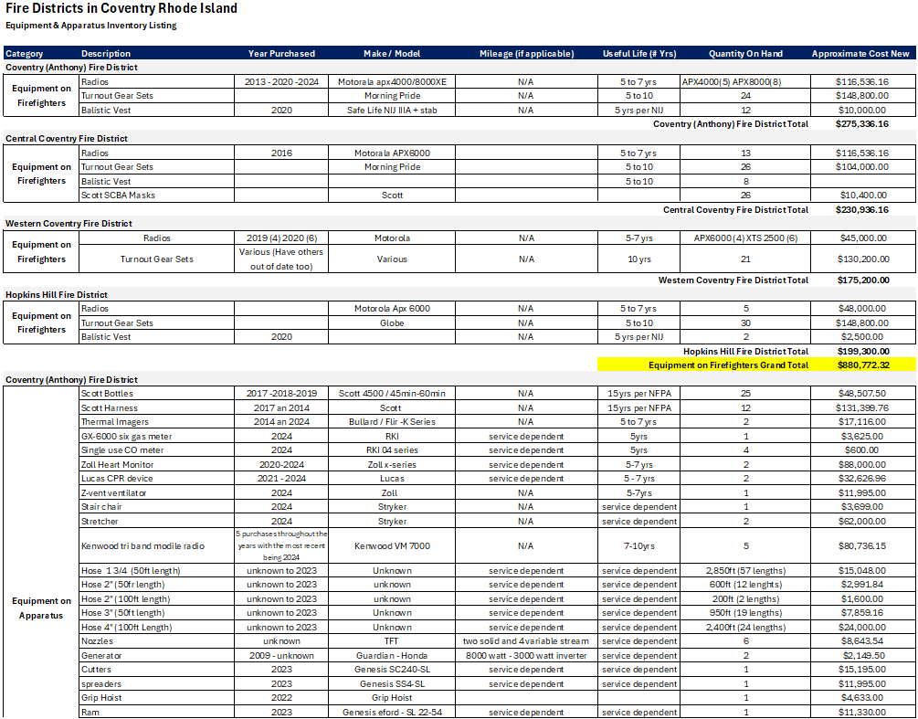
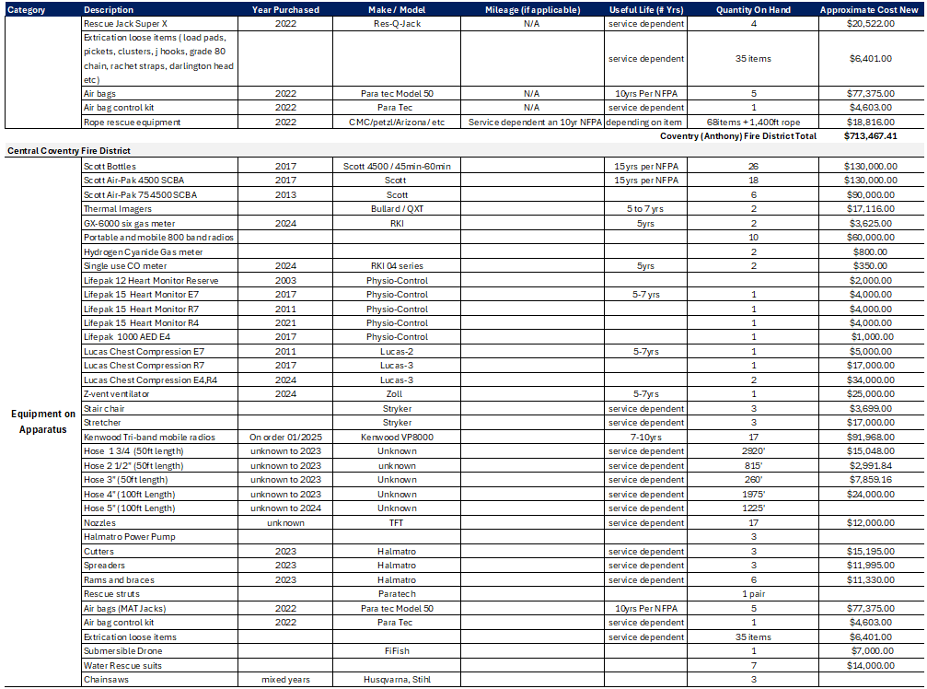
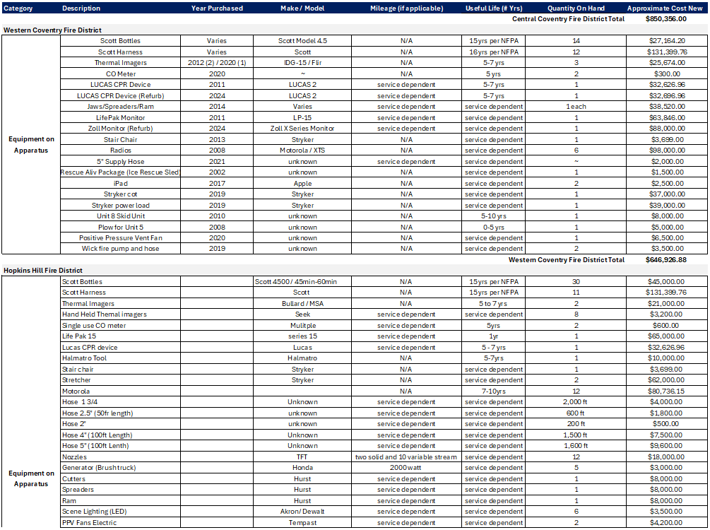
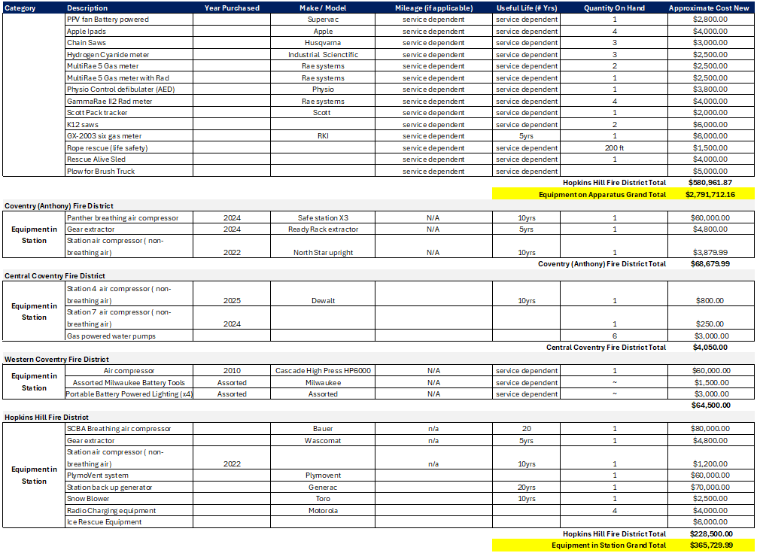
Figure 4: Inventory of Equipment
7.3 Acquisition and Inventory of District Personnel

Current Staffing
The current firefighter headcount, not including chief positions include:
- CFD: 12
- CCFD: 28
- HHFD: 9
- WCFD: 5
The total current headcount of linemen personnel is 54. Within the districts, there are 57 budgeted positions, with Chief Cady, Chief Potvin, and Chief Albro.
For current apparatus staffing levels of two, and with cross manning at most stations, the station manpower per shift required is:

- CFD: 2
- CCFD: 6
- HHFD: 2
- WCFD: 2
Each platoon shift requires 12 fire personnel. The total station manpower for this model requires four platoons, or 48 personnel. As seen above, there are currently 54, which results in an extra 6 fire personnel.

Proposed Staffing and Leadership Structure
With an extra six fire personnel, there are a couple of different scenarios that could be done. As these members are budgeted for, those funds could be used to add Battalion Chiefs to the ranking structure. The other option would be putting Rescue 7 back into service. This would be the recommended option and could be done without much increase in funding, if at all. This is outlined in a later Section 7.12. If this were to be the decision made, the required staffing levels would be (separated by district station for easier comparison purposes to above):
- CFD: 2
- CCFD:8 (additional 2 added per shift for Rescue 7)
- HHFD: 2
- WCFD: 2
With this proposed staffing level, 14 personnel would be required per platoon shift, or 56 for the total four platoons. With 54 current personnel on hand, this would require two extra firefighters.
As outlined in the current staffing model above, there are 54 budgeted firefighter positions, and three budgeted chief positions throughout the fire districts. Only one chief position would be required in a municipal fire department. In addition to this, a full-time dedicated fire marshal position is needed, especially with the recent state oversight of some school buildings due to limited current resources and the exorbitant amount of time and properties the districts include for inspections, plan review, smoke certificates, etc.
The four dispatchers are currently not included in the fire district manning budgets. It would need to be decided upon by the Town Council and/or future Fire Chief if these dispatcher positions remain separated from the firefighters, or if they would be added in with their current budget funding them.

Collective Bargaining Agreements
At the start of this Commission, there were two professional unions with separate collective bargaining agreements. One union represented CFD and CCFD, and the other represented HHFD. WCFD personnel are not currently part of a union.
At the time of this report being written, HHFD has joined the CFD and CCFD union. These three districts have their own contract with different end dates; however it was verified that it would be seamless to create one for the total group when the time comes. In the event of a municipal fire district, this union would remain, with the WCFD personnel having the option of joining. This would limit any legalities of multiple collective bargaining agreements being in place and would allow for a streamlined process.

NFPA 1710: Structure Fire Staffing Requirements
The National Fire Protection Association, or NFPA, is a private organization that writes standards of safety. Rhode Island, like many states, adopts and amends some of these standards into law, such as NFPA 1 Fire Code, or NFPA 101 Life Safety Code. One standard of NFPA that fire departments aim to achieve is NFPA 1710 Structure Fire Staffing Requirements. This standard sets parameters for staffing requirements during a fire event to ensure safety of everyone involved, including firefighters and the affected public alike. It outlines the minimum requirements for staffing and response times for career fire departments.
The purpose of NFPA 1710 is to:
- To ensure effective, efficient, and safe fire emergency services
- To minimize risks to life and property by providing timely and adequate response
- To guide the deployment of fire department resources based on risk and hazard assessment
- To provide a framework for consistent and standardized emergency response
NFPA standards are not laws unless they are adopted by a jurisdiction, they are often used in legal proceedings and considered benchmarks in the standard of care in the fire service.
Proper staffing limits unsafe working conditions by allowing for appropriate apparatus to respond, as well as appropriate personnel to respond. Every firefighter has a job depending on the event, command needs, and apparatus they are manning. If not, enough personnel arrive at a call, it could cause unsafe conditions for rescue missions of trapped occupants, rescue missions of trapped firefighters, among other situations.
In his report to the Commission, Lt. Kevin E. McCann, CCFD, described the NFPA 1710 minimum staffing requirements and the challenges the current fire districts find in meeting this standard. Each individual district does not meet NFPA 1710 minimum requirements. The Coventry Municipal Fire Commission has been tasked with transitioning from individual fire districts into a municipal department to increase and stabilize the Fire/EMS services for the Town of Coventry.
In referencing the standard, each district, as a stand-alone entity, does not meet the NFPA 1710 standard if responding to a single-family dwelling fire. The districts rely on an automatic aid agreement established in the past years to assist in response. This agreement has been taxed over the last few years and has created tensions between the districts with respect to protecting their own districts, maintenance of vehicles, and injuries to fire personnel. Issues like those mentioned have placed apparatus out of service and districts lacking manpower.
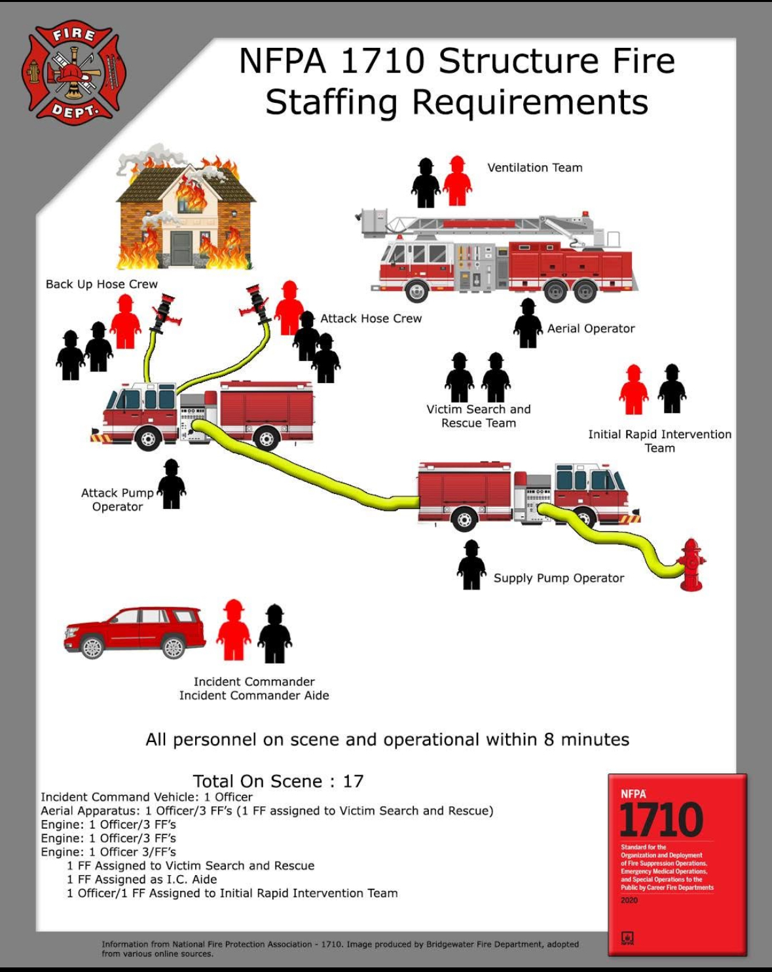
Figure 5: NFPA 1710 Residential Structure Fire Staffing Requirements

As seen in Figure 5 above, a residential structure fire requires seventeen firefighter personnel arriving and operating at the scene within eight minutes. An example of current conditions is a fire in western Coventry would initially receive a response from the members of WCFD and CCFD Station 7, with other responding districts and surrounding towns. This would have an initial two-man truck from Station 8 and two man truck from Station 7 arriving on scene, four firefighters, typically within ten to fifteen minutes at the far end of the WCFD district. Further time would allow for other responding agencies to arrive on scene.

Future Growth
Future growth was addressed; however, this would be for after the municipal fire department was created. This growth included putting Rescue 7 into service, as discussed in the previous section, as well as putting a second apparatus into service at Station 8. This second apparatus would greatly benefit the western end of town, whose taxpayers often see a dangerous response time when the first apparatus from that station is on another call, oftentimes resulting in the station being unmanned. The response times that have been witnessed in this scenario can be fatal in some situations, such as cardiac arrest, anaphylactic shock, entrapment in a fire, etc. To put a second manned apparatus into service, eight firefighters would need to be added to the roster.
Longer-tern plans to consolidate to four stations (Washington Street, Bestwick Trail, Flat River Road, Victory Highway) were also discussed, while ensuring that five rescues and three engines are available to improve service, reduce missed calls, and extend apparatus lifespan.

7.4 Inventory of current third-party District contracts and transition planning for associated services
Each district has current third-party contracts for building maintenance, apparatus maintenance, and certain pieces of equipment. This includes, but not limited to fire alarm and sprinkler systems, apparatus oil changes and other services, plymovent maintenance, etc.
Third-party contracts for CFD, CCFD, and HHFD have been compiled and can be found in Figure 6 below. The WCFD BoD did not provide maintenance contracts.
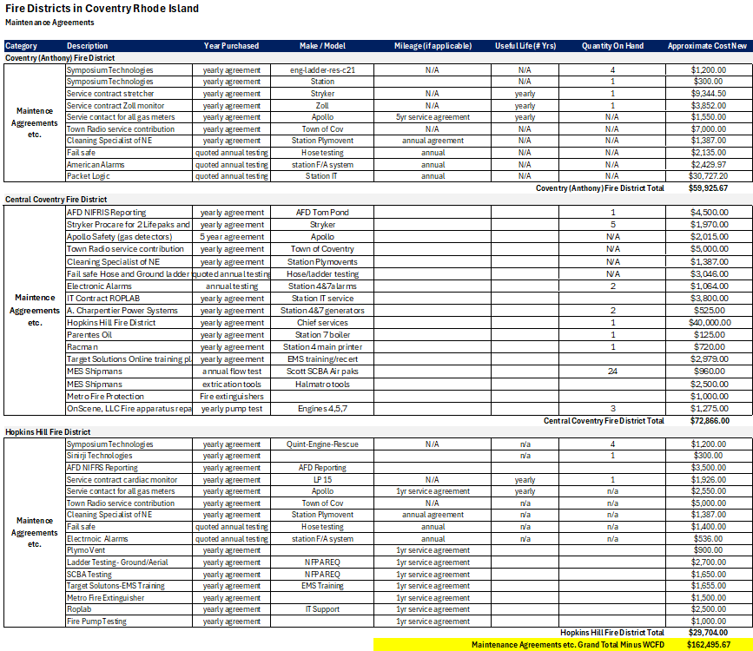
Figure 6: Third Party Maintenance Contracts
A municipal fire department would still continue to require the third-party contracts; however, they would be consolidated into one contract per item. This would most likely cause savings; however, the amount of savings would not be known until discussions with companies are had for quotes.

7.5 Assessment of District building and asset management
Although this item was included in the implementation plan outline, it was determined to be a duplicate of the apparatus, equipment, and maintenance contract assessments in the above three report sections.
The next step would be gathering the third-party maintenance and service contracts from WCFD to determine the full scope and scale for all assets and where savings could be across the four fire districts if they were to be put into one municipal contract instead of four separate contracts.

7.6 Assessment and transition planning from District tax collection to Town collection
As the fire districts have a variety of fiscal years and subsequent billing cycles that are not in line with that of the Town, a plan is required to be made to align the billing and collection cycles. As the fire districts only bill taxpayers once per year, some thought needs to be given on how billing and fiscal years will be aligned with the Town tax bills. Additionally, if property owners have outstanding bills owed to a fire district, a plan would be required to be in place on if the Town would assume those as owed revenue, those properties be subject to a tax sale, etc. Further discussion on this matter can be found later in this report in the solicitor’s attachment.
Additionally, consideration needs to be given to how the current (2025) senior tax freeze will be impacted by the formation of a municipal department. As the bills sent out by individual fire services do not allow for a senior tax freeze, it is likely that compensation will need to be made for the loss of revenue due to the senior tax freeze when the departments are combined.

7.7 Audit of collective District liabilities and outstanding debts
There are district liabilities, such as the apparatus loans of the WCFD Rescue and Engine/Tanker and the WCFD Summit Station mortgage that the town would need to absorb. These liabilities are currently budgeted for in the fire taxes, which would not be reduced in the event of the formation of a municipal fire department. These liability notes would need to be transferred from the individual fire districts to the Town of Coventry.
Although an action item on the original outline, the Commission did not create a deficit reduction plan. However there would be savings from reducing duplicate administrative positions, chief positions, and potentially combining third-party contracts, which are touched upon in other sections of this report.

7.8 Assessment and Implementation Plan of necessary, policies, codes, and ordinances to be adopted by the Town Council
The town solicitor has analyzed the policies, codes, and ordinances necessary to form a municipal fire department. The findings can be found in that separate report in Attachment B: Municipal Fire Department formation Memorandum of Town Solicitor

7.9 Assessment and implementation plan of necessary state legislation to accompany the transition
The town solicitor has assessed the necessary routes required for state legislation and has put together the findings in an implementation plan to assist with this transition to a municipal fire department. This can be found in Attachment B: Municipal Fire Department formation Memorandum of Town Solicitor

7.10 Assessment of recurring revenue and fee structure for a municipal department
A municipal fire department would absorb the recurring revenue currently collected from taxpayers and adjust according to the district to make all taxpayers are on an equal field. Analysis of the 2024 tax roll indicates that unifying the fire tax across the districts under the Town purview would:
- Stabilize tax levy fluctuations by distributing cost equitably across the town.
- Potentially reduce the tax burden in high-levy districts by leveling the rate town-wide.
- Support scalable budgeting aligned with multi-year implementation and staffing models.
The 2024 Town tax roll, fire district tax roll, and the effect it would have combined into one can be seen below in Figures 7&8:

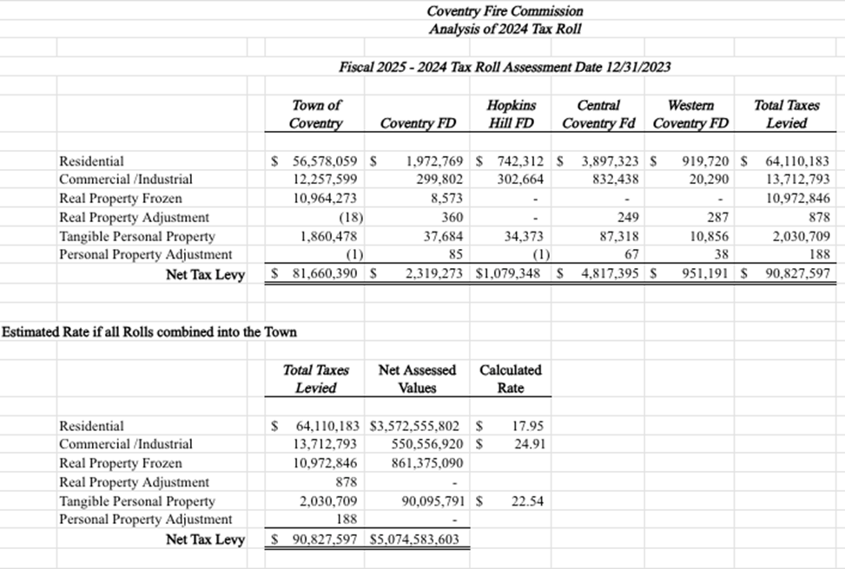
Figure 7:Tax Roll Assessment
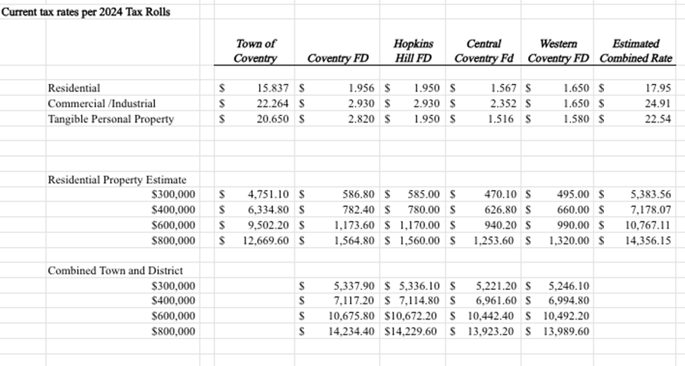
Figure 8: Combined Tax Roll Assessment

7.11 Draft budget for a municipal department for fiscal year one
The budget modeling allows for the current staffing levels to remain as is. In the future, the Commission recommends increasing this staffing level to allow for the full staffing of Engine 8, which does not currently occur with the staffing of Rescue 8, as well as the full staffing of Rescue 7, which is currently not operational due to manpower.
Figure 9 below illustrates the draft budget for the start of a municipal fire department with the current district staffing levels remaining:

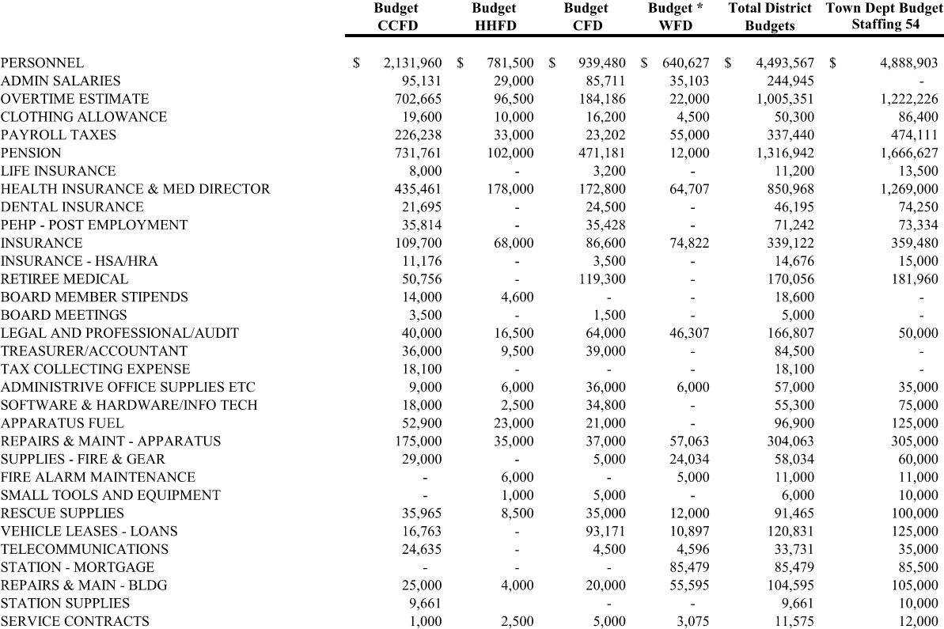
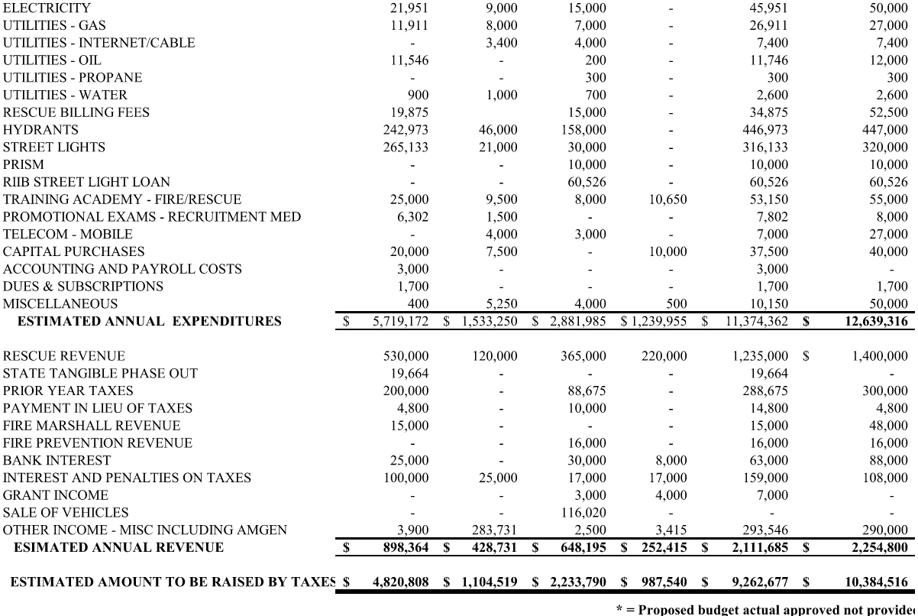
Figure 9: Municipal Fire Department Draft Budget

7.12 Assess the overall fiscal impact on the Town budget
The above proposed draft budget for the initial phase of a municipal fire department was then put against the current fiscal year 2026 tax rate to determine the overall fiscal impact on the Town budget. As seen in Figure 10 below, the increase in the tax rate of the Town would be 16.82 percent. However, this does not consider the taxes that are raised currently in each fire district. As seen in Figure 11 below, the combined Town and fire tax rate would vary depending on which fire district a taxpayer is a part of as each currently has their own differing tax rate. These fire tax increases are:
- CFD: 3.97%
- CCFD: 6.30%
- HHFD: 4.01%
- WCFD: 5.79%
Historically, each district has kept yearly fire tax increases between three and four percent per year. There have been years that have seen some districts increase taxes by over seven percent as well. Analyzing the numbers above as well as the previous increases, it can be seen that a municipal fire department formation would not increase taxes by more than what fire districts have done in the recent past. It should also be noted that WCFD does not have a separate commercial fire tax, with businesses currently paying at the residential tax rate.
This analysis does not take into account the potential purchase of WCFD assets. If the Town Council ultimately decides to create a municipal fire department, the Commission urges them to discuss this potential purchase with the WCFD BoD to determine the best path forward and to also address the issue with the taxpayers of WCFD. This asset assumption is also discussed in the Solicitor’s report in Attachment B with a potential path forward as well through the General Assembly in lieu of purchasing.
The numbers and tax rate increases are on the high side. For example, the analysis includes all members taking a family medical plan, compensation on the higher tiers, and that higher compensation creates greater MERS and tax payments. As stated in the beginning sections of this report, it is imperative that there are appropriate staffing levels, and if a municipal fire department is created, it should be a priority to put Rescue 7 back in service and fully man two apparatus at Station 8. With the inflated numbers, there may be opportunity to do one of these action items once the actual values have been settled based on member selections of insurance, everyone not being on the highest step of the pay scale, etc. This would not be known until a municipal fire department was formed and the dust had settled. Ideally both action items in the western end of town need to happen in the near term.
All increases would be subjected to municipal finance approval.
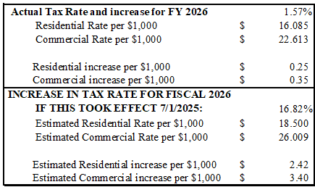
Figure 10: Town Tax Rate Increase
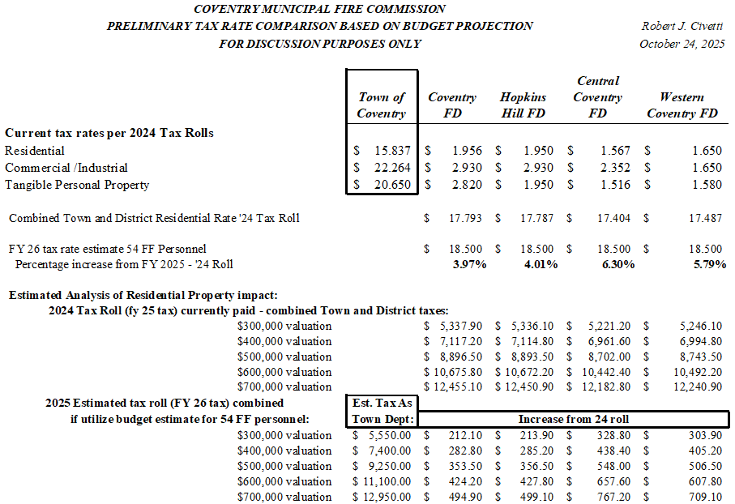
Figure 11: Tax Rate Increase by District and Residential Property Impact
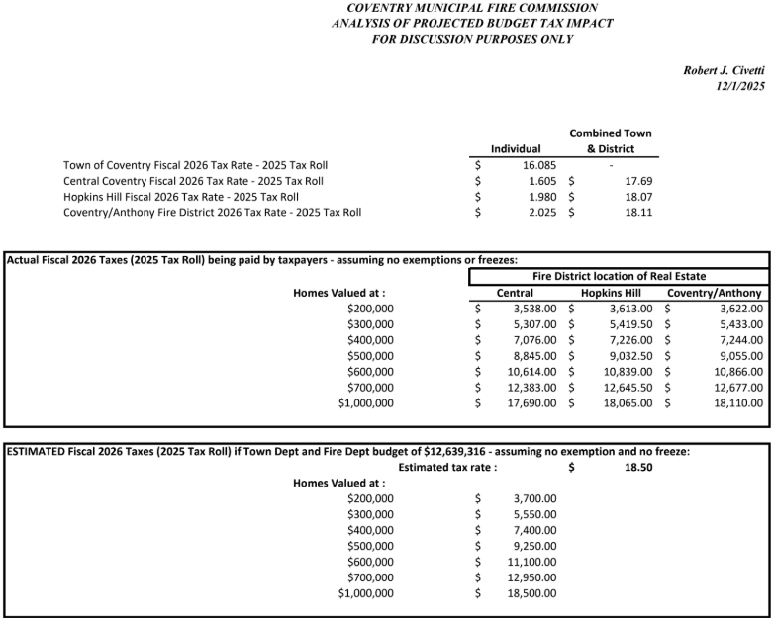
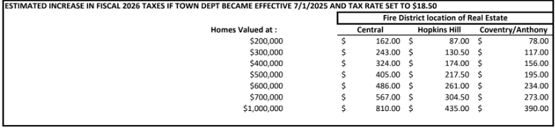
Figure 12: Estimated Impact if Fire Districts Became Town Department as of 07/01

8.0 Further Considerations

Potential Savings
In addition to the financial data outlined above, there are projected administrative redundancies that would have an estimated $455,000 in savings annually from eliminating duplicate costs. These administrative redundancies include, but are not limited to, audit costs, legal expenses, tax collectors, clerks, payroll services, and treasurers. Although a position for each of these would be required, there would no longer need to be four of each as there is now in the fire district model.

Capital Improvement Plan (CIP)
If the Town were to absorb fire district assets, consideration should be given to the cost of a future capital improvement plan. This plan should include:
- Facility repairs and modernization
- Apparatus replacement schedule
- Consideration of long-term station consolidation

Debt and Pension Liability
If the Town were to create a municipal fire department, the current fire district debt and pension liabilities would also be absorbed. Please see Attachment 3 for current pension information obtained from MERS from CFD, CCFD, and HHFD. WCFD does not currently have a pension and utilizes a 401k system instead.
A MERS study should be conducted to determine future pension obligations In addition to this, a resolution to conduct a MERS study needs to be put in front of the Town Council. This study should include the process of adding WCFD personnel and combining the current three districts into a municipal fire department and is estimated to cost $15,000. As seen in Attachment 3, the current funding includes:
- CFD: $3M UAL (60.2% funded)
- CCFD: $4.18M UAL (76.9% funded)
- HHFD: ($134,264) UAL (102% funded)
- WCFD: 401k match up to 3%
It is helpful to understand that the entire pension liability is not debt due at one given time. Only the amount to be paid to firefighters who are actually retired is due in any given year.
In addition to pension liability, other fire district debt was also gathered. The total combined debt across all four districts is approximately $2.2M, with an annual combined debt service being $345,000. It should also be noted that WCFD obtained an engine/tanker apparatus in November 2025, after these calculations were completed. This new apparatus has a loan of $160,000 and is to be paid quarterly for four years.

9.0 Comparative Evaluation of Service Models
While the charge of the Commission was to evaluate the establishment of a municipal fire department, the following table lists the pros and cons of options the Town/Fire Districts have:
Option | Pros | Cons
Status Quo  (Four Independent Districts) | - Preserves district control  - No legal changes needed | - Ongoing instability  - $455K+ in redundant costs  - Unequal service & pay  - Fragmented accountability
One Unified Independent  Fire District | - Some savings  - Simplified governance | - Financial risks from shared debt  - Still outside Town control  - Requires cooperation & legal steps
Eastern Districts Unified  (Two Independent  Fire Districts) | - Targets most critical areas  - Avoids WCFD opposition | - Leaves system fragmented  - Mutual aid imbalance persists
Eastern Municipal Department & Independent WCFD Remains | - Town gains control of majority  - Limits legal conflict | - Fragmentation remains  - WCFD under-resourcing continues  - Legal issues with WCFD having two tax bills
Municipal Fire Department | - Direct Town oversight  - Stable and equitable service | - Requires legislation, CBA integration  - Potential resistance from some districts

10.0 Conclusion
The Commission submits this report to the Coventry Town Council as a summary of its work between January and July 2025. This report presents factual findings, draft scenarios, and detailed analysis to support the Council in evaluating potential paths forward for Coventry's fire and EMS service structure.
The Commission did not take a formal vote or make a single unified recommendation. Instead, the group has worked to objectively present data, explore trade-offs, and outline legal and operational considerations associated with each of the service models under discussion.
The decision of what direction to take with these findings now rests with the Town Council. The Commission hopes that this report will assist the Council in making an informed policy decision that addresses the long-term needs of Coventry residents and first responders.

